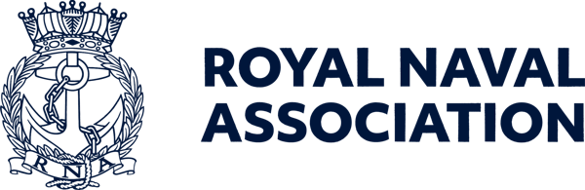

Semaphore Short Friday 22 May 2026

Naval Service Memorial appeal passes £10,000

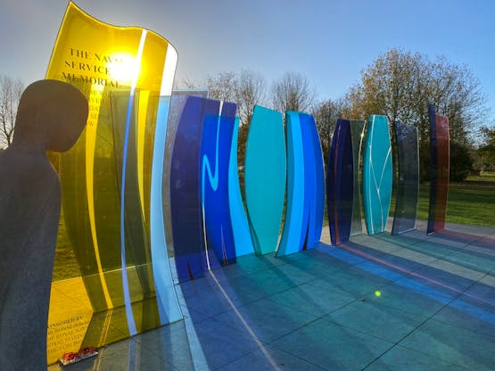

The Association’s appeal for the repair and maintenance of the Naval Service Memorial (NSM) has now passed £10,000 – a huge thank you to everyone, individuals and branches, who have contributed.
The monument, featuring eye-catching multi-coloured glass panels, was unveiled at the National Memorial Arboretum at Alrewas, in Staffordshire, in 2014, but has suffered from water ingress damage requiring repairs using seals which were not available 12 years ago.
Once the repairs are completed, it is intended that a comprehensive maintenance programme will be put in place in perpetuity.
Please contribute where you can, to enable us to repair and maintain the NSM for all future visitors to enjoy, ensuring its longevity. You can donate through https://www.justgiving.com/campaign/navalservicememorial
And if you get the chance, please visit the Arboretum, which is five miles north of Lichfield and six miles south-west of Burton-upon-Trent – a truly thought-provoking experience. For more on the Arboretum see https://www.thenma.org.uk

  The final push is on for the RNA 2026 membership survey, which will enable us to understand all members’ views on the Association and its activities.
  And for one lucky entrant, drawn at random, there will be a £100 Amazon gift voucher for their trouble.
  Completing the survey will help us to deliver more of what members want and need – and if you could all add your email addresses, this would enable us to communicate more effectively with members.
  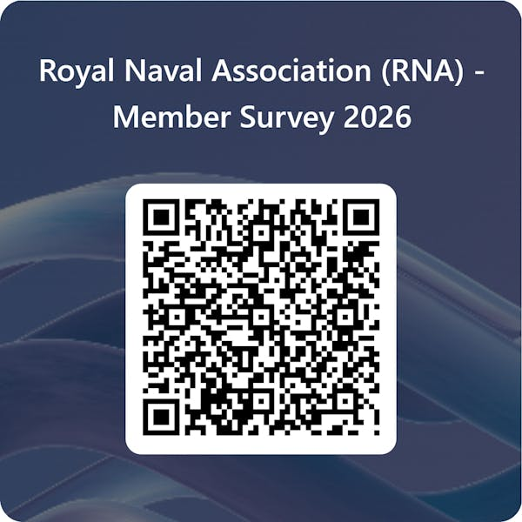

Branch secretaries – tell your shipmates how important it is that we get a wide cross-section of views from the membership! If every one of you could get six shipmates to complete the survey we would be able to make sure the Association is more closely aligned with its members' expectations. To take part please use the QR code (right) or go to this link: https://forms.office.com/e/wbauj6qJmm

Conference programme
We are now just three weeks from the start of the National Conference weekend in Salford, and organisers have put together a splendid programme for shipmates visiting Greater Manchester.
The weekend starts with the RNA Golf Tournament at Ellesmere Golf Club on the morning of Friday 12 June, with a Meet and Greet for arriving delegates, observers and their nearest and dearest on Friday evening at Craft Brew in Salford Quays.
The RNA Annual General Meeting is on Saturday 13 June at the Lowry, with a gala dinner in the evening at the Imperial War Museum North.
The formal part of the weekend closes with a Drumhead Service on the morning of Sunday 14 June adjacent to Dock 10 at Media City.
For those with a little time to spare, as well as enjoying the attractions of Salford Quays there is also the chance to watch the UK Chinese Dragon Boat Festival, which takes place on the water over the weekend.
Further details of the Conference programme will be published in the June Semaphore Circular, out on Friday 5 June, and the full programme with detailed timings and locations will be available at the Meet and Greet on the Friday evening.

There is still time to nominate a delegate...
There is still time for your Branch to nominate a delegate to attend the AGM on the Saturday of Conference weekend (13 June) and take an active part in the vital business of running this great Association.
Nominations must be received at RNA Central Office not less than one week before the date of the Conference – any queries should be directed to Sara on 023 9272 3747.
Please note: A delegate will not be confirmed as such unless or until the Branch Balance Sheet for 2025 and Branch Annual Report for 2025 have been received in RNA Central Office.
Should either not have been received in Central Office, the delegate's status will be deemed to be that of an observer.
The relevant delegate nomination form is at the back of the May edition of the Semaphore Circular, which can be found on the RNA website athttps://www.royal-naval-association.co.uk/category/semaphore-circular

  Uckers is upon us
  The Uckers season - is there such a thing? - is now in full swing, with the Scottish Area having seen a thrilling contest which went right to the wire – read more in the June Semaphore Circular.
  Next up is the Welsh Open on Saturday 6 June at Builth Wells Rugby Club – for details see page 21 of the MaySemaphore Circular (which can be found athttps://www.royal-naval-association.co.uk/category/semaphore-circular.
  The grand finale to the season is the RNA Uckers World Championships at the Royal Maritime Hotel in Portsmouth on Saturday 3 October.
  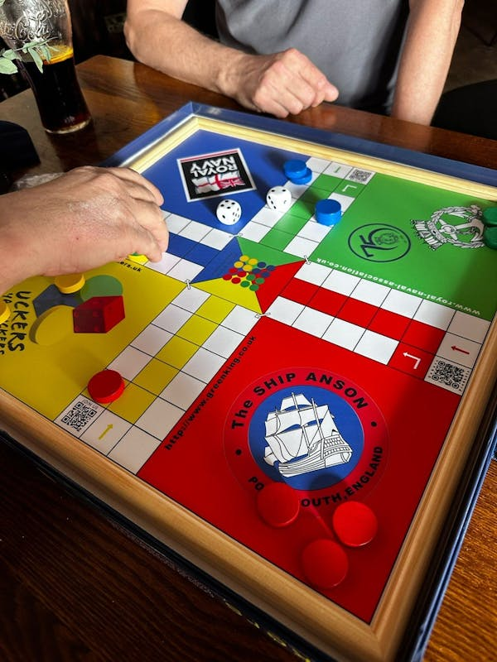

Bob's bench is dedicated

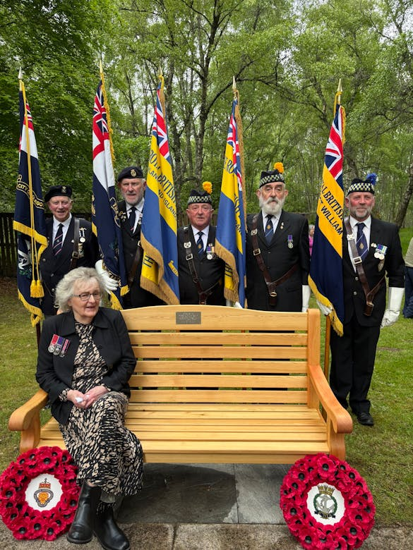

Members of the Scottish Naval and veterans’ communities gathered for a poignant service to dedicate a memorial bench in remembrance of the late S/M Bob Coburn BEM.
The ceremony brought together friends, shipmates and supporters to honour Bob’s life, service, and lasting contribution to the community of Beauly and the wider Scottish military family. The well-attended event was a fitting tribute, reflecting the high regard and affection in which Bob was held.
Bob, who was RNA National Standard Bearer amongst many roles he undertook for the Association and the Royal British Legion, died in November 2023 at the age of 77, just days after learning he had been awarded the British Empire Medal.

Surf's up for RNA group

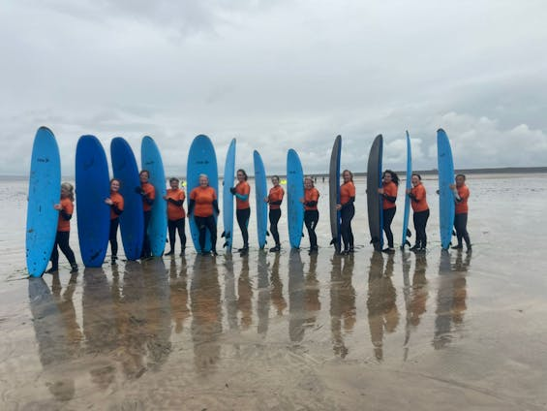

A group of individuals connected by the Naval community recently swapped everyday pressures for the challenge of donning wetsuits and climbing on surfboards in North Devon.
The surfing weekend, held in Westward Ho!, was organised through the RNA’s Thriving Together programme and brought together women from across the UK, including veterans, serving personnel and members of the wider Naval community.
While the surfing was the central theme for the weekend, time together to share experiences and relax with like-minded people proved just as valuable for those who attended.
For more pictures and a report see the RNA Website athttps://www.royal-naval-association.co.uk/from-service-to-surfboards-women-veterans-find-connection-in-north-devon, and the event will also feature in the June Semaphore Circular.

  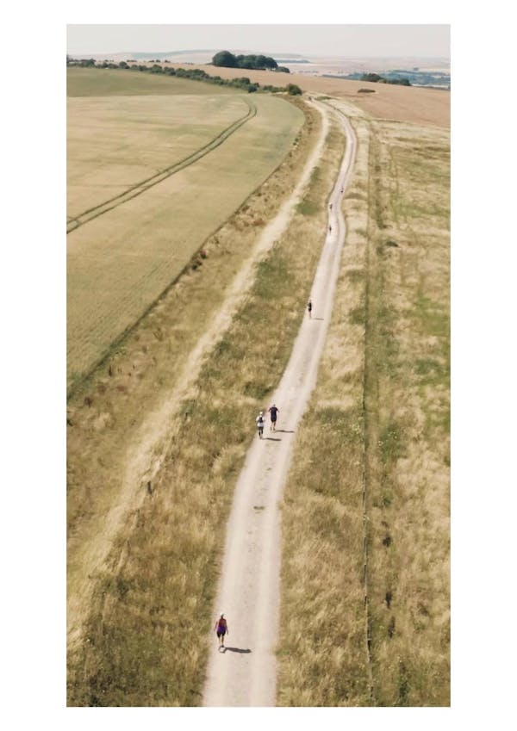
  Ultra – easy!
  Have you got what it takes to conquer the oldest path in Britain? The Ridgeway has been walked for over 5,000 years. Can you follow in our ancestor drovers' footsteps and walk or run 100km on the weekend of 11-13 July in support of SSAFA? There's also a 50km option.
  You have one or two days to complete the course from Lewknor on Oxfordshire to the prehistoric Avebury Stones in Wiltshire, with a basecamp at Wantage, and there’s 20 per cent off the registration fee from tomorrow until the end of the month.
  This is a fully-supported event with a great campsite and pit-stops, making it one of the UK's most popular UltraUltra Marathons.

It’s an ideal starter Ultra and you really can do it at a walk… but if you are super-fit, it’s one of the most competitive Ultras in the UK too – hang on to your PBs!
Fundraise to support SSAFA's work within the Armed Forces community – SSAFA works closely with the RNA welfare team to provide assistance when a Shipmate needs it most.
For ful details go to https://www.ssafa.org.uk/support-us/events/ultra/race-to-the-stones-2026/

 |  |  |  |  |  |  |  |  |  |  | 

